EV ÖDEVİM
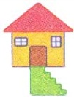
s s s s s s s s s s s s s s s
s s s s s s s s s s s s s s s
s s s
s s
s
S S S S S S S S S S S S
S S S S S S S S S S S S
S S
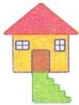
S

