Varlıkların isimlerini yuvarlak içine alalım.Satırlara yazalım.

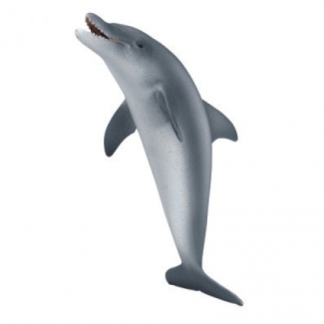 yaz

|  |  |  |  |
| --- | --- | --- | --- |
| saat | simit | kayısı | yunus |

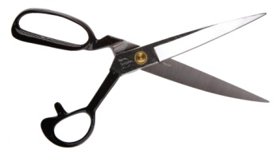

|  |  |  |  |
| --- | --- | --- | --- |
| taksi | sert | makas | sarı |

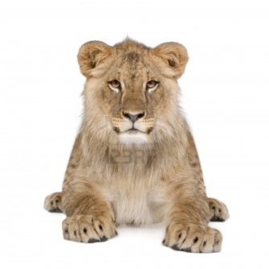

|  |  |  |  |
| --- | --- | --- | --- |
| maske | salata | salı | aslan |

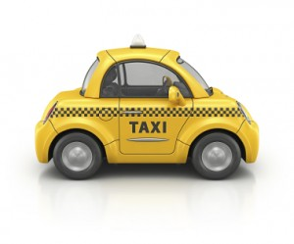

|  |  |  |  |
| --- | --- | --- | --- |
| tas | sat | set | taksi |

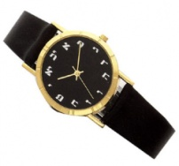

|  |  |  |  |
| --- | --- | --- | --- |
| sen | saat | sana | suluk |

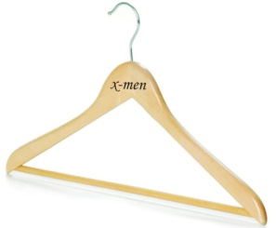

|  |  |  |  |
| --- | --- | --- | --- |
| as | su | ast | askı |

|  |  |  |  |
| --- | --- | --- | --- |
| kes | keser | kesik | kestane |

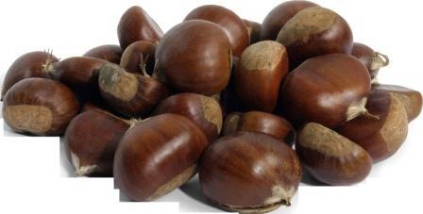

|  |  |  |  |
| --- | --- | --- | --- |
| say | soy | yastık | yas |

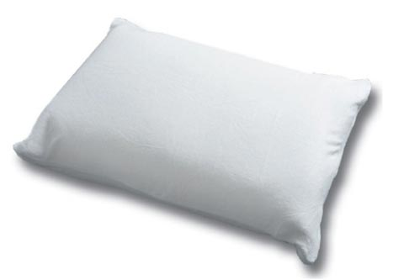

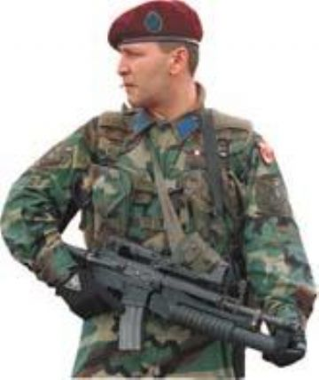

|  |  |  |  |
| --- | --- | --- | --- |
| asi | asit | asker | teras |

|  |  |  |  |
| --- | --- | --- | --- |
| masa | masal | saman | serin |

[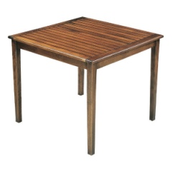](http://www.google.com.tr/url?sa=i&rct=j&q=masa+resmi&source=images&cd=&cad=rja&docid=XTWxeTnes95nTM&tbnid=3mOnUPfPDTeCyM:&ved=0CAUQjRw&url=http://tutkunmutfakcelikkapi.rehberalem.com/ms-134Iki-parcali-dogum-masasi-1.html&ei=W98CUcHZBcyLhQeR8YGgBA&bvm=bv.41524429,d.bGE&psig=AFQjCNExMi7slne-39-rPxJILb5mRwMarw&ust=1359229147578974)

|  |  |  |  |
| --- | --- | --- | --- |
| sim | simay | simit | siren |

[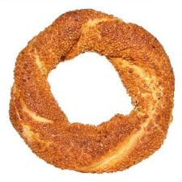](http://www.google.com.tr/url?sa=i&source=images&cd=&cad=rja&docid=pgbvPzdEnTfiSM&tbnid=1egiC4juJA5aAM:&ved=0CAgQjRwwAA&url=http://www.meleklermekani.com/teknik-destek/196826-metin2-oyununda-simit-nerden-duser.html&ei=WucCUdG2BZGYhQfIw4CADg&psig=AFQjCNFuicMw_WjLofxADx9LBTqEy1RiSQ&ust=1359231194127120)

[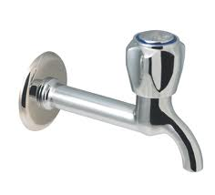](http://www.google.com.tr/url?sa=i&rct=j&q=musluk+resmi&source=images&cd=&cad=rja&docid=laiqT9GeEl_9JM&tbnid=UgG-8m3vWMbY2M:&ved=0CAUQjRw&url=https://www.enucuzyapimarket.com/default.asp?git=9&urun=2942&ei=8TQEUZHZJMSnhAf4wYG4Bw&psig=AFQjCNGKwk-aVZcrVXmXZiSMFTt-ohUTKw&ust=1359316594021282)

|  |  |  |  |
| --- | --- | --- | --- |
| su | musluk | sat | taslak |