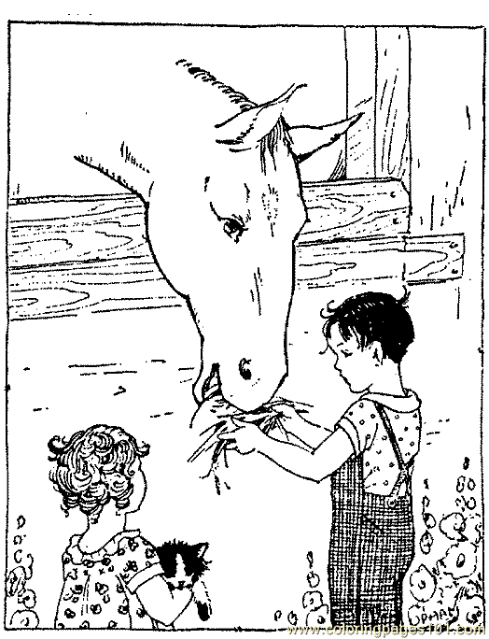
Ara Tara
Erol ot ara.
Ara, tara, ot ara
O at terli terli.
Onu narin narin tara.
Nil ata iri ot at.
Tart Erol tart.
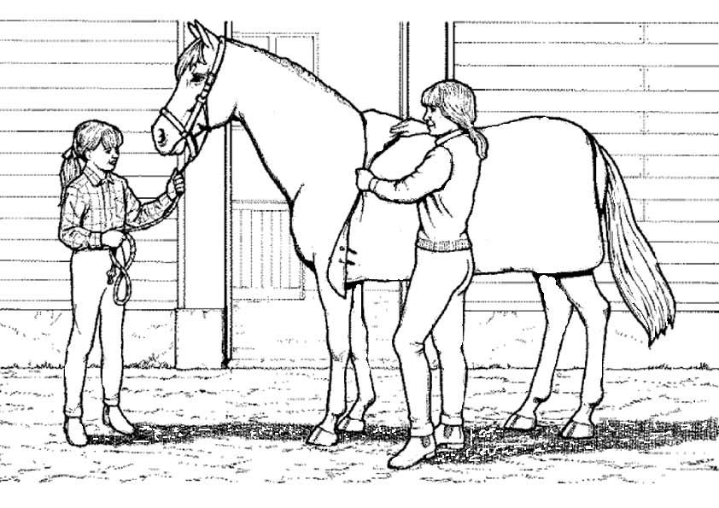
Erol ata iri ot tart.

On tere.
Rana elli lira al.
Tere al, nar al.
Tane tane tere al.
Tane tane nar al.
İri iri nar ara.
On tere on lira.
On nar on lira.
