[](http://www.google.com.tr/imgres?um=1&sa=N&hl=tr&rlz=1T4VASJ_trTR510TR528&tbm=isch&tbnid=V-faL4pRmK6eNM:&imgrefurl=http://www.tahinpekmez.org/?m=show&sa=7933&docid=iiOWDraiUNH7XM&imgurl=http://www.tahinpekmez.org/uploads/images/sivribiber/ada-b12531.jpg&w=500&h=375&ei=KubHUtG4I-mN7AaNyIGICA&zoom=1&iact=hc&vpx=2&vpy=211&dur=1125&hovh=194&hovw=259&tx=115&ty=86&page=2&tbnh=141&tbnw=180&start=15&ndsp=20&ved=1t:429,r:15,s:0,i:12)[](http://www.google.com.tr/imgres?um=1&sa=N&hl=tr&rlz=1T4VASJ_trTR510TR528&tbm=isch&tbnid=noXw9sEx-adX5M:&imgrefurl=http://www.uludagsozluk.com/k/%C3%B6zg%C3%BCrl%C3%BCk%C3%A7%C3%BC-kedi-hareketi/&docid=86sNLMLuTmlzAM&imgurl=http://galeri5.uludagsozluk.com/6/%C3%B6zg%C3%BCrl%C3%BCk%C3%A7%C3%BC-kedi-hareketi_46847.jpg&w=800&h=600&ei=st7HUunIFIOThgeq04CgBA&zoom=1&iact=hc&vpx=718&vpy=136&dur=3344&hovh=194&hovw=259&tx=172&ty=92&page=1&tbnh=136&tbnw=178&start=0&ndsp=15&ved=1t:429,r:4,s:0,i:9)[](http://www.google.com.tr/imgres?start=126&hl=tr&biw=1024&bih=540&tbm=isch&tbnid=Vjnu677A37jYqM:&imgrefurl=http://www.haber5.com/guncel/bu-dede-guinnesse-girecek&docid=wSQCspwJUMUOWM&imgurl=http://haber5.net/haber/13/01/11/1428/bu-dede-guinnesse-girecek.jpg&w=615&h=326&ei=sN3HUpbrH4mihgfUxoCABA&zoom=1&iact=hc&vpx=515&vpy=258&dur=2250&hovh=163&hovw=309&tx=152&ty=81&page=7&tbnh=143&tbnw=228&ndsp=21&ved=1t:429,r:40,s:100,i:12)

RESMİN ALTINA ADLARINI YAZALIM

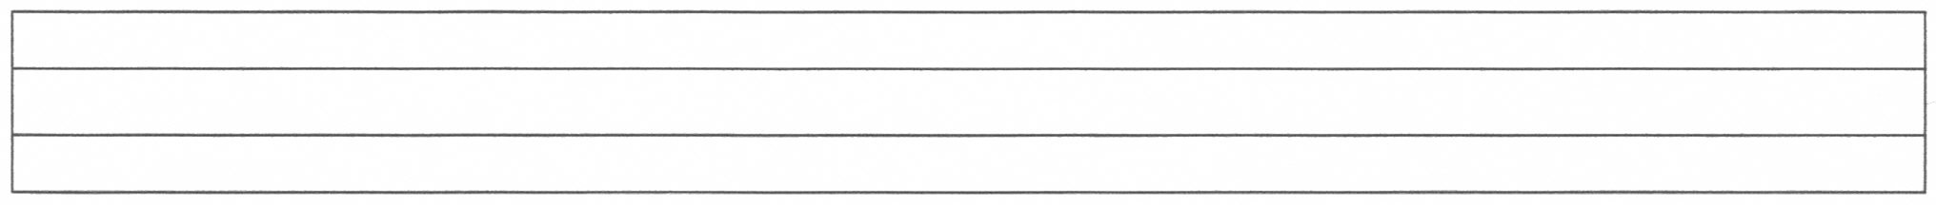



  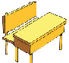 



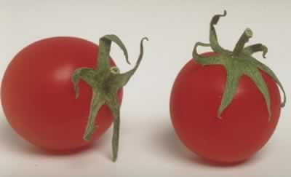

[](http://www.google.com.tr/imgres?um=1&sa=N&hl=tr&rlz=1T4VASJ_trTR510TR528&tbm=isch&tbnid=0iLTKmC7czkTiM:&imgrefurl=http://aliduyar.com/sayilarin-bize-hatirlattiklari-2/&docid=bpEjdlOcCV8WJM&imgurl=http://aliduyar.com/wp-content/uploads/7.png&w=1000&h=1000&ei=UeXHUs2bCIWshQfr0IHACQ&zoom=1&iact=rc&page=1&tbnh=139&tbnw=139&start=0&ndsp=19&ved=1t:429,r:9,s:0,i:104&tx=73&ty=8)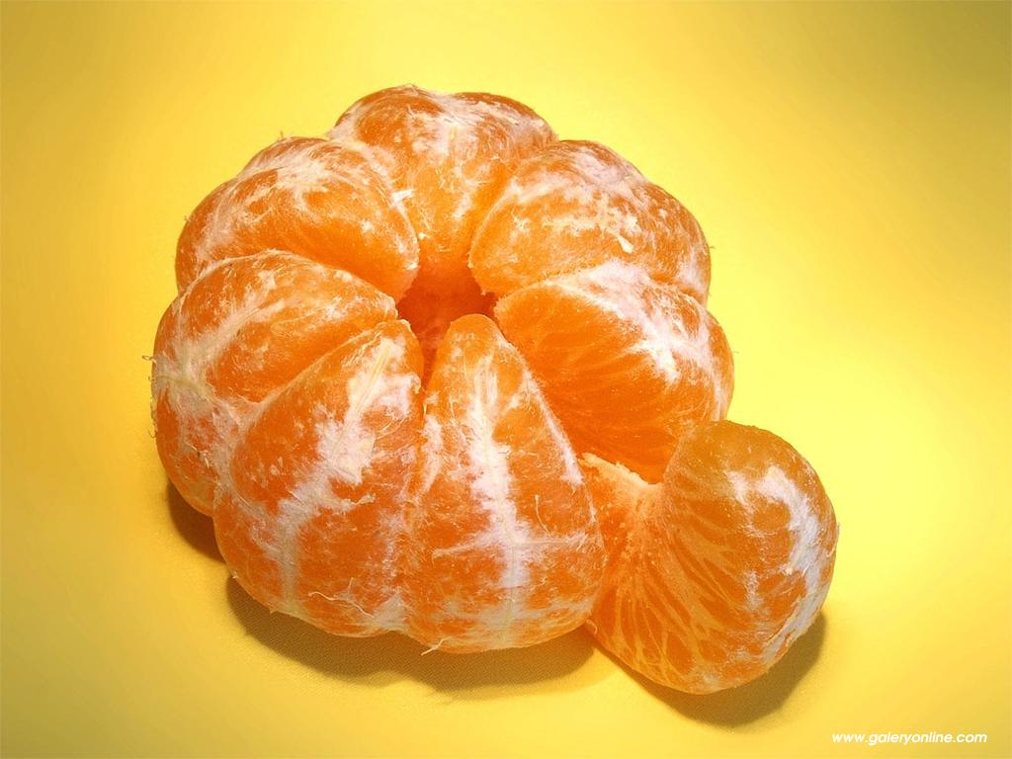



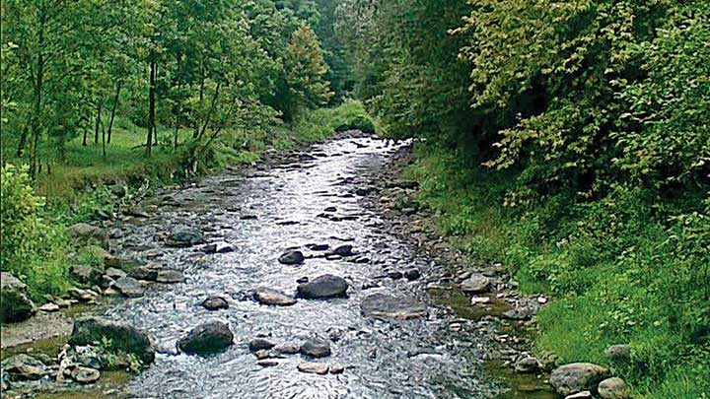 





[](https://elblogdelamariona.wordpress.com/2011/03/27/numeros-amb-color-1-9/gif_1237-cartoon-character-happy-numbers-2/)   



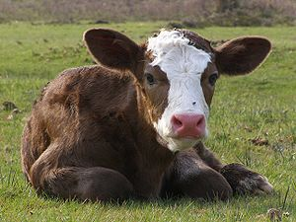   [](http://www.google.com.tr/url?sa=i&rct=j&q=&esrc=s&source=images&cd=&cad=rja&uact=8&ved=0ahUKEwipmY-Q99HJAhVDMhoKHVEuCpAQjRwIBw&url=http://tr.clipart.me/premium-transportation/road-cartoon-vector-and-illustration-isolated-on-white-background-334974&bvm=bv.109395566,d.bGg&psig=AFQjCNHseqtS3B2Rgu5z5YZxCT6DLdArjA&ust=1449858815292826) [](http://www.google.com.tr/url?sa=i&rct=j&q=&esrc=s&source=images&cd=&cad=rja&uact=8&ved=0ahUKEwiUr__I89HJAhVMSRoKHZUhClYQjRwIBw&url=http://pt.depositphotos.com/13290728/stock-photo-snake-cartoon-character.html&bvm=bv.109395566,d.bGg&psig=AFQjCNG813qaTaWhFLIRA_Z7M8hC-4M0QQ&ust=1449857860132220)





 [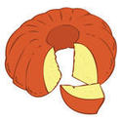](http://www.google.com.tr/url?sa=i&rct=j&q=&esrc=s&source=images&cd=&cad=rja&uact=8&ved=0ahUKEwifh8ygoMDJAhXHPBoKHSzNDPcQjRwIBw&url=http://tr.clipartlogo.com/premium/detail/halloween-illustration_115262344.html&bvm=bv.108538919,d.d2s&psig=AFQjCNGi9ypMoC-Z8fPxmQCnjl9bHjeKbw&ust=1449251355402839)   



   



 