Adım, Soyadım:………………………………… Sonuç:……………………

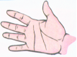

j0252349FSTNR008

|  |
| --- |
|  |
|  |
|  |

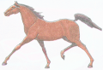

|  |
| --- |
|  |
|  |
|  |

|  |
| --- |
|  |
|  |
|  |

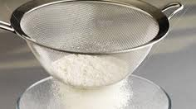 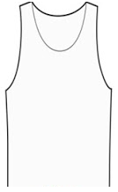

|  |
| --- |
|  |
|  |
|  |

|  |
| --- |
|  |
|  |
|  |

|  |
| --- |
|  |
|  |
|  |

[](http://www.google.com.tr/url?sa=i&rct=j&q=&esrc=s&frm=1&source=images&cd=&cad=rja&docid=iOZnuQlQdS6SIM&tbnid=xe0f_GUMom4ccM:&ved=0CAUQjRw&url=http://www.atasampanelcit.com/&ei=-pOCUtepFMidtQbo-4CACA&bvm=bv.56146854,d.Yms&psig=AFQjCNEA5h8sbubO3N_mcywCcX_Ej16RbA&ust=1384375652688762) 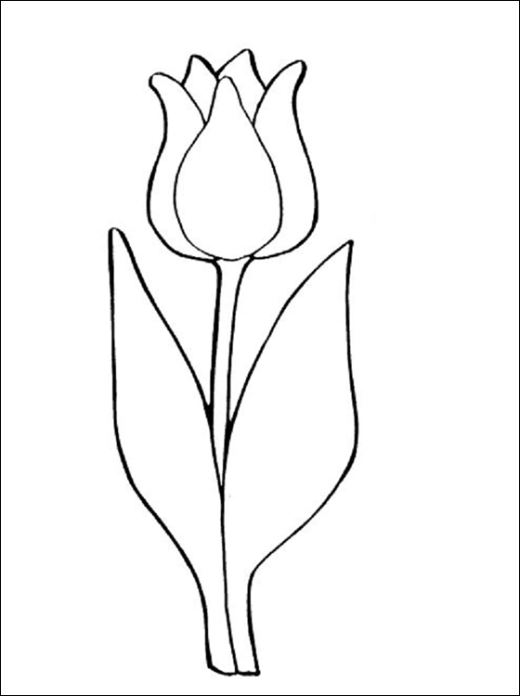 

|  |
| --- |
|  |
|  |
|  |

|  |
| --- |
|  |
|  |
|  |

|  |
| --- |
|  |
|  |
|  |



50

|  |
| --- |
|  |
|  |
|  |

|  |
| --- |
|  |
|  |
|  |

|  |
| --- |
|  |
|  |
|  |

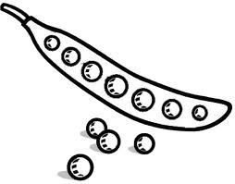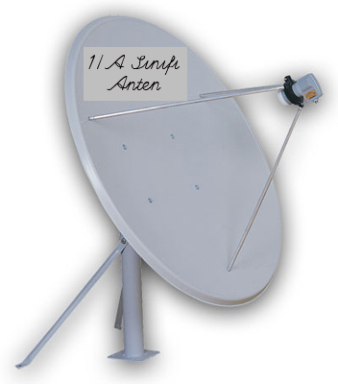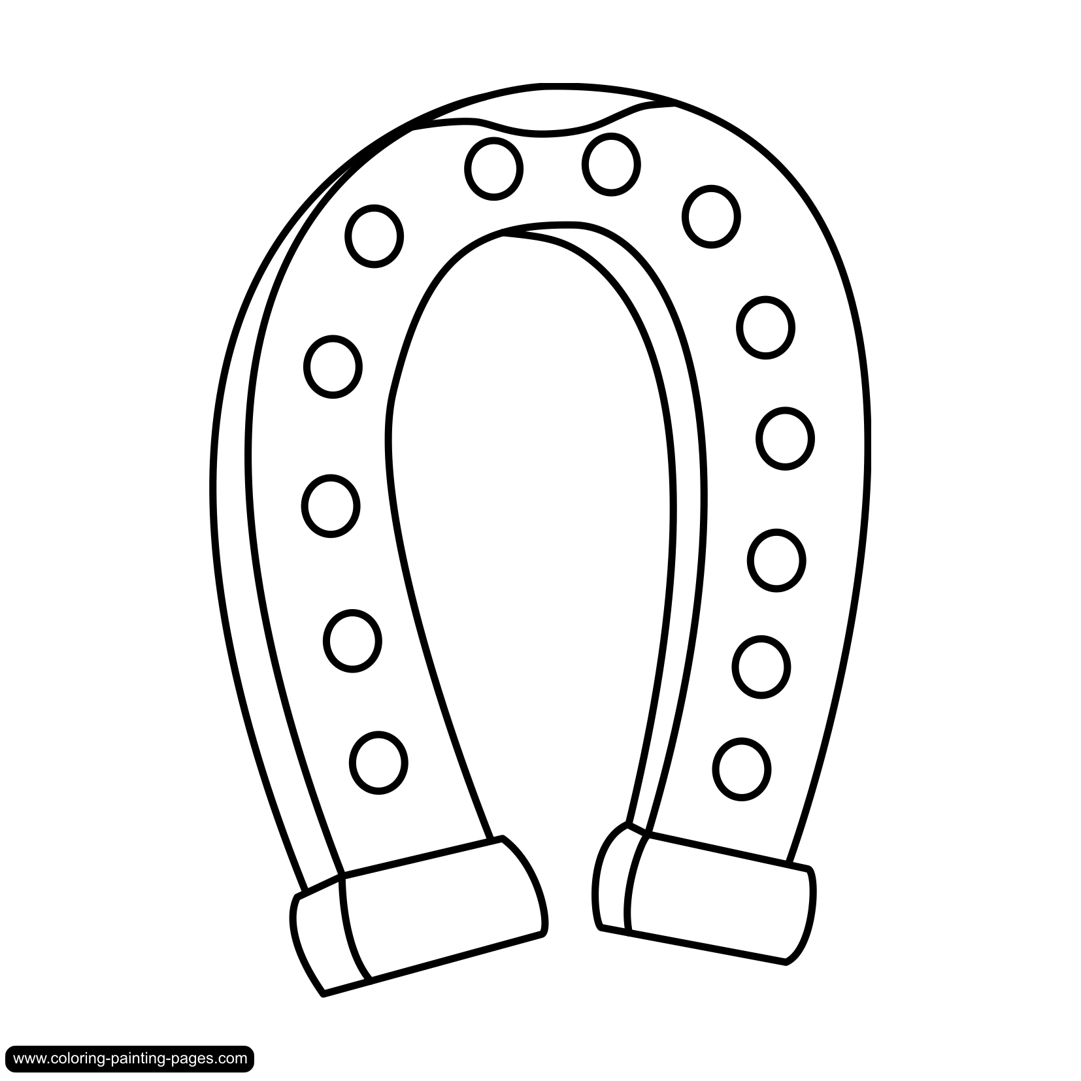

|  |
| --- |
|  |
|  |
|  |

|  |
| --- |
|  |
|  |
|  |

|  |
| --- |
|  |
|  |
|  |

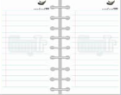

[](http://www.google.com.tr/url?sa=i&source=images&cd=&cad=rja&docid=XjdhOlpbdtUSgM&tbnid=PWy02LpG8rzATM:&ved=0CAgQjRwwAA&url=http://www.pepee-oyunlari.com/oyun/31/caillou-ip-atlama-oyunu.html&ei=46GfUpasINSg7Ab0pYCQDw&psig=AFQjCNFBwNC2lWtBd6jCgjPRSsp-X5f85A&ust=1386279779598808)

|  |
| --- |
|  |
|  |
|  |

|  |
| --- |
|  |
|  |
|  |

|  |
| --- |
|  |
|  |
|  |

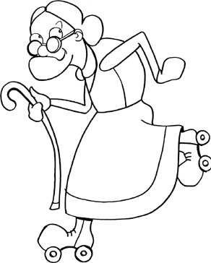

Veli İmza:………………………

|  |
| --- |
|  |
|  |
|  |