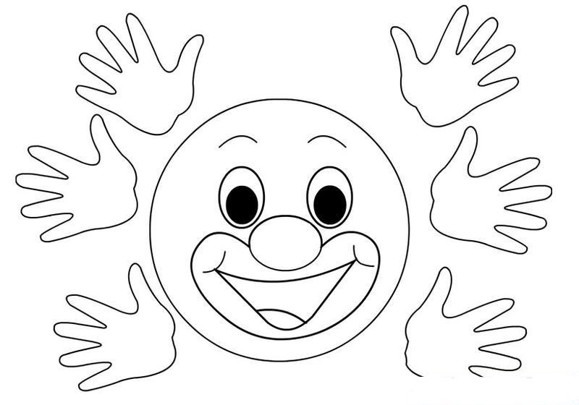
mama
mantar
amele
tema
metal
metan
mental
emet
amel
Emel
eleme
Temel
mera
mil
rama
tarama
Metin
Emin
Emine
Emir
Mira
Mina
Minel
Amira
Mine
Emre
Emret
Tamer
İmren
Mert
Meral
İrem

