6
l l l l l l l
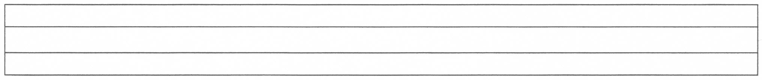
lllllllllllllllllllllllllllllllllllllllllll
lllllllllllllllllllllllllllllllllllllllllll

lllllllllllllllllllllllllllllllllllllllllll
lllllllllllllllllllllllllllllllllllllllllll
lllllllllllllllllllllllllllllllllllllllllll
lllllllllllllllllllllllllllllllllllllllllll

lllllllllllllllllllllllllllllllllllllllllll
lllllllllllllllllllllllllllllllllllllllllll
lllllllllllllllllllllllllllllllllllllllllll

lllllllllllllllllllllllllllllllllllllllllll
lllllllllllllllllllllllllllllllllllllllllll

