atlat

C:\Users\özgem\AppData\Local\Microsoft\Windows\Temporary Internet Files\Content.IE5\WR1YWMQX\MC900232046[2].wmf

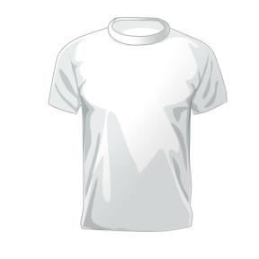

atlet

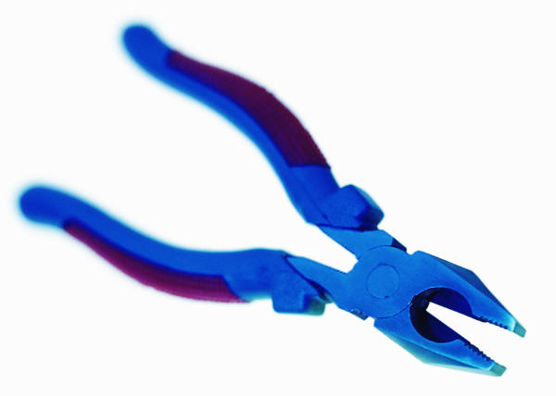

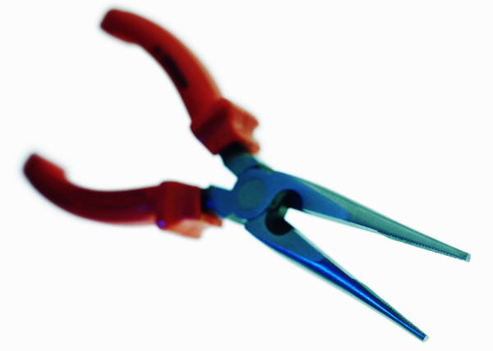

alet