2
eee eee e
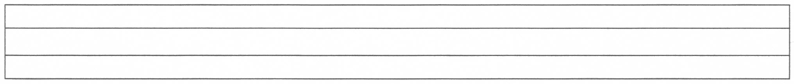
eeeeeeeeeeeeeeeeeeeeeeeeeeeeeeeeeee
eeeeeeeeeeeeeeeeeeeeeeeeeeeeeeeeeee

eeeeeeeeeeeeeeeeeeeeeeeeeeeeeeeeeee
eeeeeeeeeeeeeeeeeeeeeeeeeeeeeeeeeee
eeeeeeeeeeeeeeeeeeeeeeeeeeeeeeeeeee
eeeeeeeeeeeeeeeeeeeeeeeeeeeeeeeeeee

eeeeeeeeeeeeeeeeeeeeeeeeeeeeeeeeeee
eeeeeeeeeeeeeeeeeeeeeeeeeeeeeeeeeee

eeeeeeeeeeeeeeeeeeeeeeeeeeeeeeeeeee
eeeeeeeeeeeeeeeeeeeeeeeeeeeeeeeeeee

