9
eee E lll L
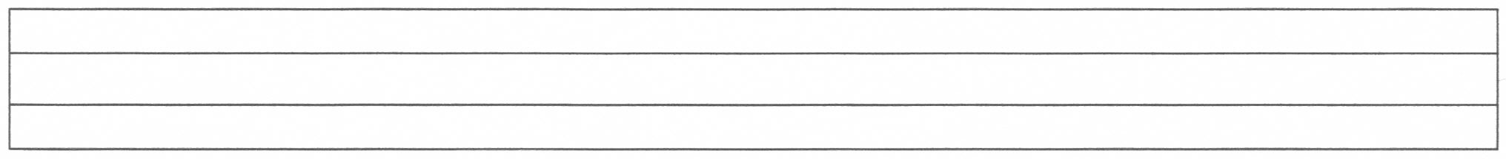
E E E E E E E E E E E E E E E
e e e e e e e e e e e e e e e e e

e e e e e e e e e e e e e e e e e
L L L L L L L L L L L L
l l l l l l l l l l l l l l l l l l l

l l l l l l l l l l l l l l l l l l l
eeeeeeeeeeeeeeeeeeeeeeeeeeeeeeeeeee
eeeeeeeeeeeeeeeeeeeeeeeeeeeeeeeeeee

lllllllllllllllllllllllllllllllllllllllllll

lllllllllllllllllllllllllllllllllllllllllll

