15
a a a
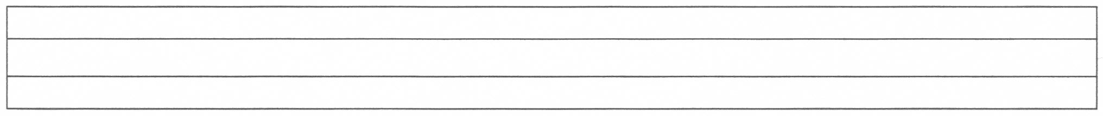
a a a a a a a a a a a a a a
a a a a a a a a a a a a a a

a a a a a a a a a a a a a a

a a a a a a a a a a a a a a
a a a a a a a a a a a a a a

a a a a a a a a a a a a a a
a a a a a a a a a a a a a a
a a a a a a a a a a a a a a

a
a
a

