18
A A A
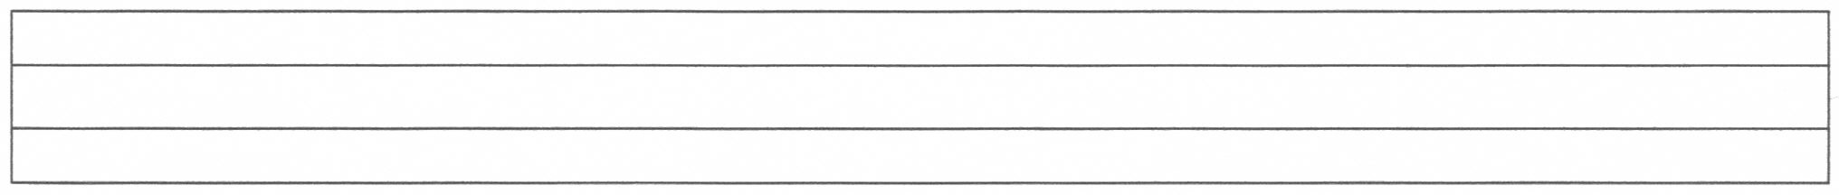
A A A A A A A A A
A A A A A A A A A

A A A A A A A A A

A A A A A A A A A
A A A A A A A A A

A A A A A A A A A
A A A A A A A A A
A

A
A
A

