[](http://www.google.com.tr/url?sa=i&rct=j&q=&esrc=s&source=images&cd=&cad=rja&uact=8&ved=0ahUKEwjw163Tx_bJAhWBJBoKHetbCBwQjRwIBw&url=http://de.depositphotos.com/28934731/stock-illustration-cartoon-old-man-sitting-bench.html&bvm=bv.110151844,d.d2s&psig=AFQjCNHrA--0NpfXVPudJwKeRXp4C_c6zA&ust=1451117382096470)[](http://www.google.com.tr/url?sa=i&rct=j&q=&esrc=s&source=images&cd=&cad=rja&uact=8&ved=0ahUKEwj1j7zrx_bJAhVGVxoKHctkCpUQjRwIBw&url=http://tr.depositphotos.com/2416031/stock-illustration-smiling-cat.html&bvm=bv.110151844,d.d2s&psig=AFQjCNFVzZ1mBxo68OAV4cfTatHVJq5x5A&ust=1451117421225758) [](http://www.google.com.tr/url?sa=i&rct=j&q=&esrc=s&source=images&cd=&cad=rja&uact=8&ved=0ahUKEwjhg6alyPbJAhXB2xoKHS1lAtoQjRwIBw&url=http://tr.depositphotos.com/1256058/stock-photo-drop-blood-on-thorn-of.html&bvm=bv.110151844,d.d2s&psig=AFQjCNH3DtXRdjlUTi61mDMd3_3GuvQvhA&ust=1451117515922875) [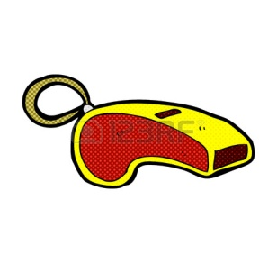](http://www.google.com.tr/url?sa=i&rct=j&q=&esrc=s&source=images&cd=&cad=rja&uact=8&ved=0ahUKEwivldq9yPbJAhWD2xoKHSSOBEcQjRwIBw&url=http://tr.123rf.com/photo_35975599_retro-%C3%A7izgi-roman-tarz%C4%B1-karikat%C3%BCr-d%C3%BCd%C3%BCk.html&bvm=bv.110151844,d.d2s&psig=AFQjCNGEBy4fLwl155nqdotDANx7llzkgg&ust=1451117606197794)[](http://www.google.com.tr/url?sa=i&rct=j&q=&esrc=s&source=images&cd=&cad=rja&uact=8&ved=0ahUKEwiE-I6GyvbJAhUBuhoKHZhoAd8QjRwIBw&url=http://www.kamudanhaber.com/7-rakami-ile-ilgili-efsaneler-p1-aid,763.html&bvm=bv.110151844,d.d2s&psig=AFQjCNE8TT6tCTq5LvzC5nyS7Dhpi9PWcA&ust=1451118025572484)

d..d.. k..d.. d..k..n ..üd..k ..e..i

[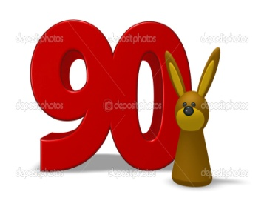](http://www.google.com.tr/url?sa=i&rct=j&q=&esrc=s&source=images&cd=&cad=rja&uact=8&ved=0ahUKEwjql_qvyfbJAhVBThoKHbi6BJ4QjRwIBw&url=http://tr.depositphotos.com/34411083/stock-photo-number-and-rabbit.html&bvm=bv.110151844,d.d2s&psig=AFQjCNE0jOuGAuIDoACdIKZKh-1r29yQKA&ust=1451117845055893) [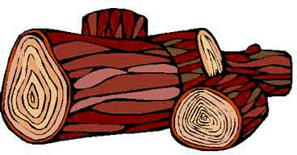](http://www.google.com.tr/url?sa=i&rct=j&q=&esrc=s&source=images&cd=&cad=rja&uact=8&ved=0ahUKEwi09N2_yfbJAhVGWRoKHV4aCSAQjRwIBw&url=http://unyezile.com/gurcuoy.htm&bvm=bv.110151844,d.d2s&psig=AFQjCNHSqULIowGD8Eou4bVN0CWLFKKLtQ&ust=1451117879067938) [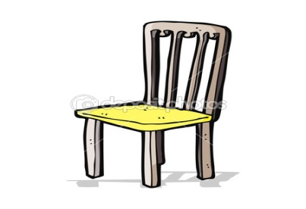](http://www.google.com.tr/url?sa=i&rct=j&q=&esrc=s&source=images&cd=&cad=rja&uact=8&ved=0ahUKEwjkm8vpyfbJAhVCWRoKHdelAjgQjRwIBw&url=http://tr.depositphotos.com/50128731/stock-illustration-cartoon-old-chair.html&bvm=bv.110151844,d.d2s&psig=AFQjCNE7Jw__AdZxQ_WgIjg_4xcHf7JXXg&ust=1451117965992217) [](http://www.google.com.tr/url?sa=i&rct=j&q=&esrc=s&source=images&cd=&cad=rja&uact=8&ved=0ahUKEwikx7DZyPbJAhXKtBoKHVC3BQ0QjRwIBw&url=http://tr.depositphotos.com/vector-images/buz.html&bvm=bv.110151844,d.d2s&psig=AFQjCNGTW6swVjD2Rg6xXwB7_hNbhFTwJg&ust=1451117663531576)

d..ks..n ..d..n s..nd..ly.. d..nd..rm..

[](https://www.google.com.tr/url?sa=i&rct=j&q=&esrc=s&source=images&cd=&cad=rja&uact=8&ved=0ahUKEwiJk4PbyfbJAhVDCBoKHYOsCOEQjRwIBw&url=https://www.pinterest.com/pin/345651340125440306/&bvm=bv.110151844,d.d2s&psig=AFQjCNHCF7xavFe_QL7_GOEyrtlFsGvx3g&ust=1451117928607311) [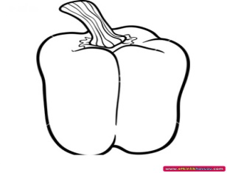](http://www.google.com.tr/url?sa=i&rct=j&q=&esrc=s&source=images&cd=&cad=rja&uact=8&ved=0ahUKEwith6GUyvbJAhXRhhoKHUFcCdAQjRwIBw&url=http://www.etkinlikhavuzu.com/etkinlik/dolma_biber_boyama/5322&bvm=bv.110151844,d.d2s&psig=AFQjCNHVzQVOh04gbAWphilk66i2cKULBA&ust=1451118054176514) [](http://www.google.com.tr/url?sa=i&rct=j&q=&esrc=s&source=images&cd=&cad=rja&uact=8&ved=0ahUKEwjq-4anyvbJAhWLcBoKHaf9BB8QjRwIBw&url=http://tr.depositphotos.com/13428089/stock-illustration-christmas-snowman-cartoon.html&bvm=bv.110151844,d.d2s&psig=AFQjCNGfr-ZH54QlQmMc3vMuO84-eInM8A&ust=1451118095239247)[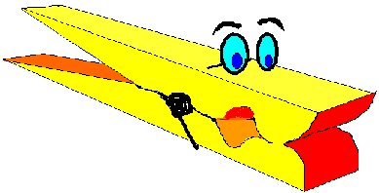](http://www.google.com.tr/url?sa=i&rct=j&q=&esrc=s&source=images&cd=&cad=rja&uact=8&ved=0ahUKEwi39oLPyvbJAhUFvBoKHe2GAlsQjRwIBw&url=http://ww1.kmarsiv.com/xfiles/mandal_1.asp&bvm=bv.110151844,d.d2s&psig=AFQjCNFcPij-mRFjZzusyRXUxXzKdbBSQw&ust=1451118167628560)

..il d..lm.. k..r..an a..am m..an..al

[](http://www.google.com.tr/url?sa=i&rct=j&q=&esrc=s&source=images&cd=&cad=rja&uact=8&ved=0ahUKEwiV49O2y_bJAhXFthoKHZnxC-IQjRwIBw&url=http://lecker-eck.de/&bvm=bv.110151844,d.d2s&psig=AFQjCNFUjEVbPoJ9msJFpJky4ByG5NWQ9A&ust=1451118346293568) [](http://www.google.com.tr/url?sa=i&rct=j&q=&esrc=s&source=images&cd=&cad=rja&uact=8&ved=0ahUKEwip9rzjyvbJAhVELhoKHR-gApIQjRwIBw&url=http://tr.depositphotos.com/4887811/stock-illustration-tomato-character-giving-thumbs-up.html&bvm=bv.110151844,d.d2s&psig=AFQjCNGgSpWKkas_YGvqrrpeFTcjEefqbw&ust=1451118220582709) [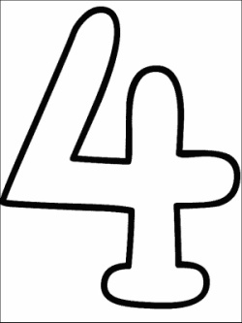](http://www.google.com.tr/url?sa=i&rct=j&q=&esrc=s&source=images&cd=&cad=rja&uact=8&ved=0ahUKEwiz3OOCzvbJAhXJhhoKHZjZDa0QjRwIBw&url=http://www.nkfu.com/4-sayisi-rakami-boyama-sayfalari/&bvm=bv.110151844,d.d2s&psig=AFQjCNG-Nolv2nAFyZ2WNMRfKOXsUBixGg&ust=1451119089758831)

..ön..r d..m..te.. d..r..

Meral ......... yedi.

odun

döner

Dursun ........kırdı.

yedi

Selma .......kere saydı.