
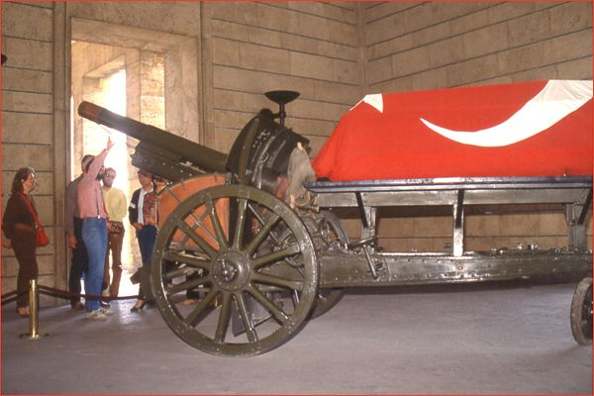
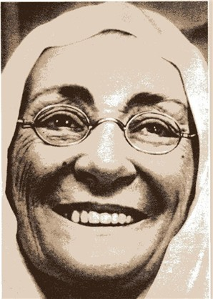
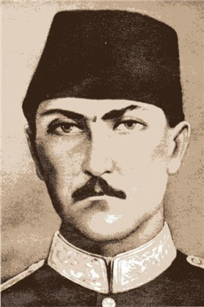
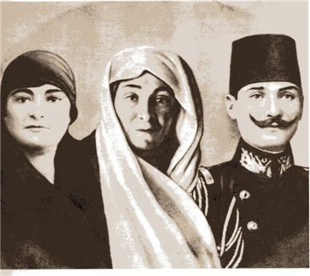
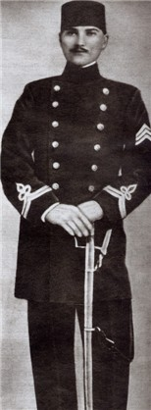
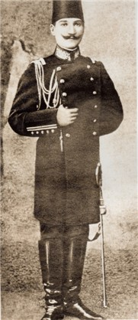
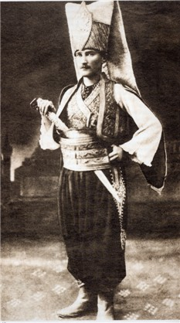
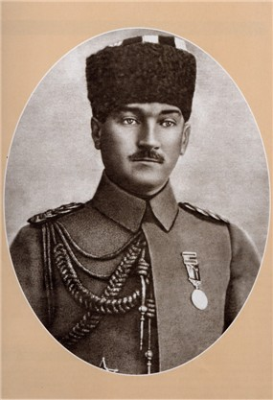
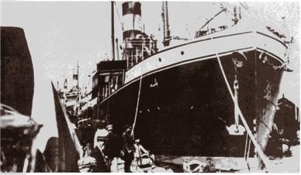
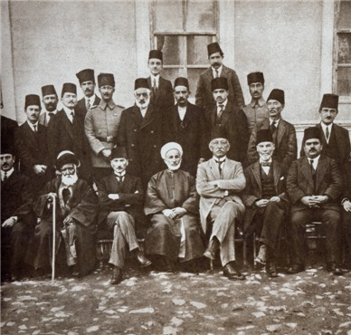
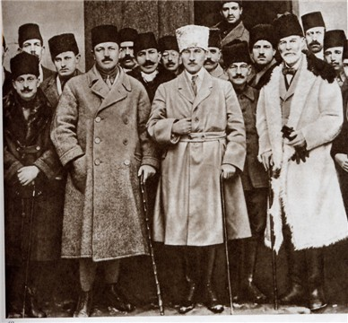
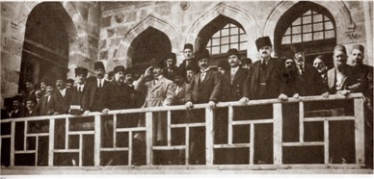
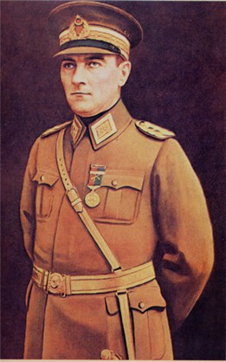
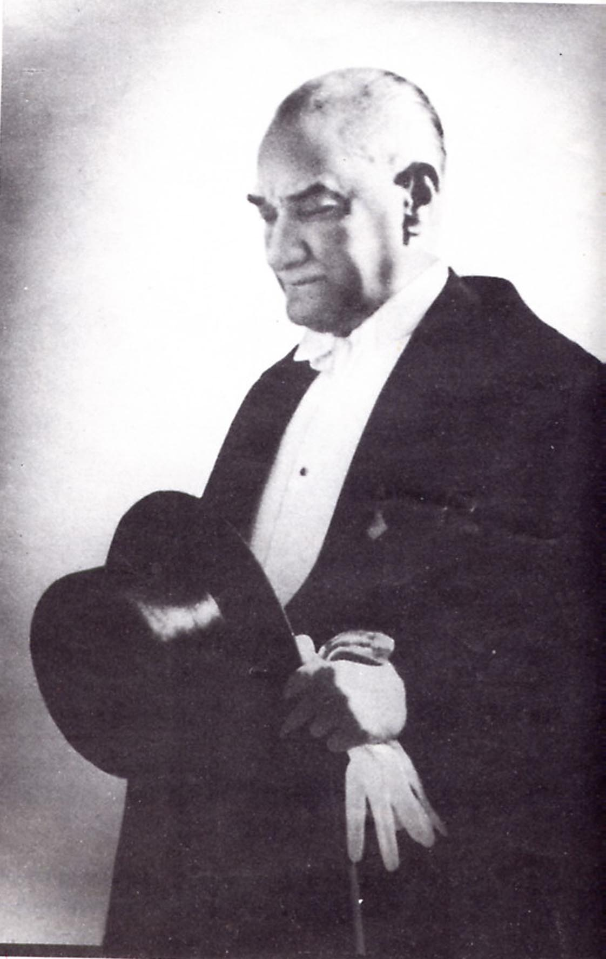

ATATÜRK’E MEKTUP

……………………………………………………………………………………………………………………………………………………………….
…………………………………………………….…………………………………………………….…………………………………………………….…………………………………………………….…………………………………………………….…………………………………………………….…………………………………………………….…………………………………………………….…………………………………………………….…………………………………………………….…………………………………………………….…………………………………………………….…………………………………………………….…………………………………………………….…………………………………………………….…………………………………………………….…………………………………………………….…………………………………………………….…………………………………………………….…………………………………………………….…………………………………………………….…………………………………………………….
ADI SOYADI :
SINIFI :
NUMARASI :

