EĞLENCELİ MATEMATİK
Adı__________________

596  x 329  ---------- | 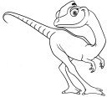 | 394  x 475  ---------- | 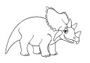 | 38  x 15  ----------
 | 383  x 16  ---------- | 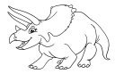 | 543  x 604  ---------- | 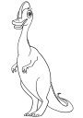
890  x 936  ---------- | 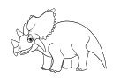 | 201  x 582  ---------- | 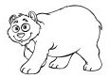 | 965  x 934  ----------
 | 619  x 198  ---------- | 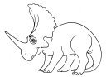 | 376  x 622  ---------- | 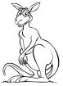
522  x 162  ---------- |  | 757  x 571  ---------- |  | 586  x 641  ----------
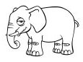 | 860  x 66  ---------- |  | 545  x 437  ----------

