EĞLENCELİ MATEMATİK
Adı__________________

305  x 349  ---------- |  | 850  x 523  ---------- |  | 494  x 379  ----------
 | 405  x 318  ---------- | 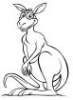 | 587  x 397  ----------
168  x 389  ---------- | 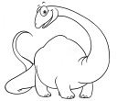 | 710  x 822  ---------- |  | 653  x 457  ----------
 | 777  x 257  ---------- |  | 597  x 880  ---------- | 
615  x 641  ---------- | 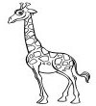 | 340  x 17  ---------- | 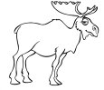 | 261  x 833  ----------
 | 698  x 122  ---------- |  | 627  x 140  ---------- | 