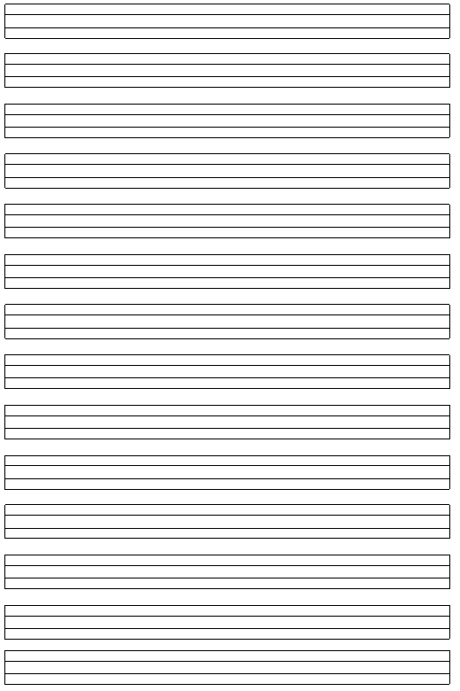
Elma on lira, nar on lira.

Metin elma ile nar al.

İri elma ile iri nar al.

Nalan on tane elma al.

Erol mor nar al, al elma al.

Emine eline et alma, ot al.

Emine, ata et atma, ot at.

