a A A a
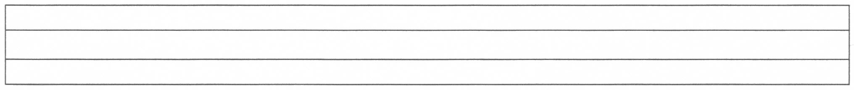
a a a a a a a a a a a a a a
a a a a a a a a a a a a a a

a a a a a a a a a a a a a a

A A A A A A A A A
A A A A A A A A A
A A A A A A A A A
a

a
A
A

