a a a a a a a a a a a a a a a a a a a a a a a a a a a a a a a a a a a a a a a a a a a a a a a a a a a a a a a a
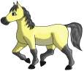

A A A A A A A A A A A A A A A A A A A A A A A A A A A A A A A A A A A A A A A A

