**BÜYÜK ÜNLÜ UYUMU**

**Türkçe kelimenin ilk hecesi kalın ünlü ile başlamışsa, sonraki heceleri de kalın, ince ile başladıysa sonraki heceleri de ince ünlü ile devam eder. Buna kalınlık-incelik ya da büyük ünlü uyumu denir. Tek heceli ve birleşik kelimelerde büyük ünlü uyumu aranmaz.**

**Kalın Ünlüler İnce Ünlüler**

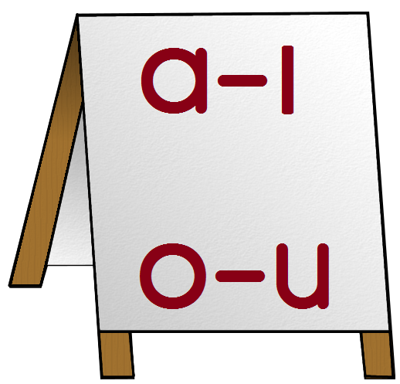 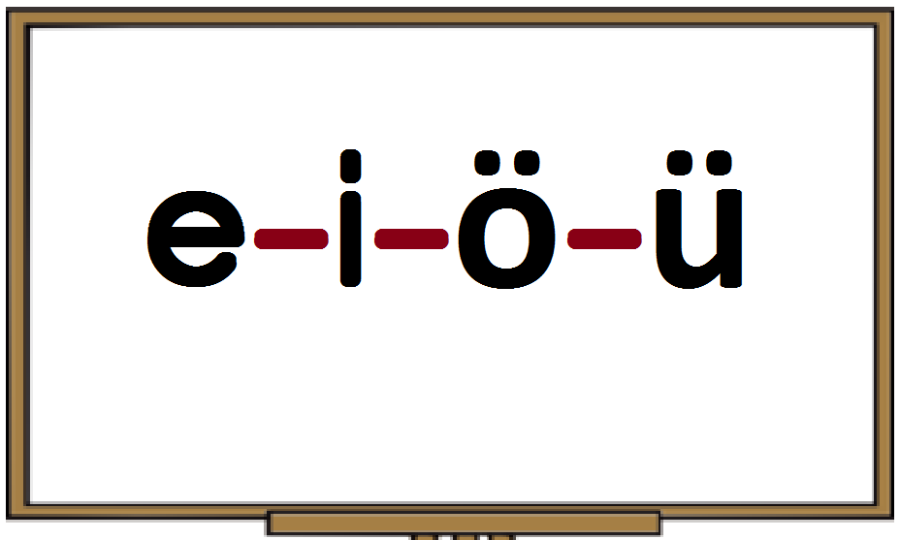

**Örnek: kavun ( Büyük Ünlü uyumuna uyar) gazete (Büyük Ünlü uyumuna uymaz)**

**kalın kalın kalın ince ince**

**Aşağıdaki kelimelerin ünlülerini örnekteki gibi ayırarak BÜYÜK ÜNLÜ UYUMU kuralına uyup uymadığını belirtiniz.**

|  |  |  |  |  |
| --- | --- | --- | --- | --- |
| **Kelime( Sözcük)** | **Kalın Ünlü**  **( Sesli)** | **İnce Ünlü**  **( Sesli)** | **Büyük ünlü uyumu kuralına Uyar** [https://encrypted-tbn0.gstatic.com/images?q=tbn:ANd9GcRxs3pb2FYBtYbZDrRPiaT4aNTpUJSQmpqZ9Cdt9kRoUVGDfCXQf3vONI8c](http://www.google.com.tr/url?url=http://publicdomainvectors.org/tr/bedava-vektor/Ye%C5%9Fil-do%C4%9Fru-vekt%C3%B6r-simgesi/8112.html&rct=j&frm=1&q=&esrc=s&sa=U&ei=aShAVMLPJYLoaoK4gJgD&ved=0CBgQ9QEwAg&usg=AFQjCNEphxi15wdZSrat2QWpnaoUAMh2Sw) | **Büyük ünlü uyumu kuralına Uymaz**[https://encrypted-tbn0.gstatic.com/images?q=tbn:ANd9GcTFmMT2f9ve6ZG8nZh-4D0mwDLYHhI7IxRCoOnCipaUOgjD1RTTb8DWzds](http://www.google.com.tr/url?url=http://gta-gold-city.blogspot.com/2013/10/blog-post.html&rct=j&frm=1&q=&esrc=s&sa=U&ei=nShAVM-iNdLeaqeigrAK&ved=0CCQQ9QEwCA&usg=AFQjCNFyN_zQ6m2HaTMFRQWYJtr3dhTI3g) |
| **Kitap**  [https://encrypted-tbn3.gstatic.com/images?q=tbn:ANd9GcRiFvarAPlqDXFOY0URrwGzUj96fxH-fhoXxhvCTsWHl087ddLXffYSq7RQ](http://www.google.com.tr/url?url=http://pixabay.com/tr/ok-yol-tarifi-sa%C4%9F-i%C5%9Faret%C3%A7i-35230/&rct=j&frm=1&q=&esrc=s&sa=U&ei=uCdAVLmoDtjjatX2gsgF&ved=0CB4Q9QEwBQ&usg=AFQjCNGndU_csM_VsK6Ns-Tau-2HQ0RerQ) | **a** | **i** |  | [https://encrypted-tbn0.gstatic.com/images?q=tbn:ANd9GcTFmMT2f9ve6ZG8nZh-4D0mwDLYHhI7IxRCoOnCipaUOgjD1RTTb8DWzds](http://www.google.com.tr/url?url=http://gta-gold-city.blogspot.com/2013/10/blog-post.html&rct=j&frm=1&q=&esrc=s&sa=U&ei=nShAVM-iNdLeaqeigrAK&ved=0CCQQ9QEwCA&usg=AFQjCNFyN_zQ6m2HaTMFRQWYJtr3dhTI3g) |
| **Kalemlik**  [https://encrypted-tbn3.gstatic.com/images?q=tbn:ANd9GcRiFvarAPlqDXFOY0URrwGzUj96fxH-fhoXxhvCTsWHl087ddLXffYSq7RQ](http://www.google.com.tr/url?url=http://pixabay.com/tr/ok-yol-tarifi-sa%C4%9F-i%C5%9Faret%C3%A7i-35230/&rct=j&frm=1&q=&esrc=s&sa=U&ei=uCdAVLmoDtjjatX2gsgF&ved=0CB4Q9QEwBQ&usg=AFQjCNGndU_csM_VsK6Ns-Tau-2HQ0RerQ) |  |  |  |  |
| **Hatıra**  [https://encrypted-tbn3.gstatic.com/images?q=tbn:ANd9GcRiFvarAPlqDXFOY0URrwGzUj96fxH-fhoXxhvCTsWHl087ddLXffYSq7RQ](http://www.google.com.tr/url?url=http://pixabay.com/tr/ok-yol-tarifi-sa%C4%9F-i%C5%9Faret%C3%A7i-35230/&rct=j&frm=1&q=&esrc=s&sa=U&ei=uCdAVLmoDtjjatX2gsgF&ved=0CB4Q9QEwBQ&usg=AFQjCNGndU_csM_VsK6Ns-Tau-2HQ0RerQ) |  |  |  |  |
| **Araştırma**  [https://encrypted-tbn3.gstatic.com/images?q=tbn:ANd9GcRiFvarAPlqDXFOY0URrwGzUj96fxH-fhoXxhvCTsWHl087ddLXffYSq7RQ](http://www.google.com.tr/url?url=http://pixabay.com/tr/ok-yol-tarifi-sa%C4%9F-i%C5%9Faret%C3%A7i-35230/&rct=j&frm=1&q=&esrc=s&sa=U&ei=uCdAVLmoDtjjatX2gsgF&ved=0CB4Q9QEwBQ&usg=AFQjCNGndU_csM_VsK6Ns-Tau-2HQ0RerQ) |  |  |  |  |
| **Edebiyat** [https://encrypted-tbn3.gstatic.com/images?q=tbn:ANd9GcRiFvarAPlqDXFOY0URrwGzUj96fxH-fhoXxhvCTsWHl087ddLXffYSq7RQ](http://www.google.com.tr/url?url=http://pixabay.com/tr/ok-yol-tarifi-sa%C4%9F-i%C5%9Faret%C3%A7i-35230/&rct=j&frm=1&q=&esrc=s&sa=U&ei=uCdAVLmoDtjjatX2gsgF&ved=0CB4Q9QEwBQ&usg=AFQjCNGndU_csM_VsK6Ns-Tau-2HQ0RerQ) |  |  |  |  |
| **Özgürlük**  [https://encrypted-tbn3.gstatic.com/images?q=tbn:ANd9GcRiFvarAPlqDXFOY0URrwGzUj96fxH-fhoXxhvCTsWHl087ddLXffYSq7RQ](http://www.google.com.tr/url?url=http://pixabay.com/tr/ok-yol-tarifi-sa%C4%9F-i%C5%9Faret%C3%A7i-35230/&rct=j&frm=1&q=&esrc=s&sa=U&ei=uCdAVLmoDtjjatX2gsgF&ved=0CB4Q9QEwBQ&usg=AFQjCNGndU_csM_VsK6Ns-Tau-2HQ0RerQ) |  |  |  |  |
| **Hürriyet**  [https://encrypted-tbn3.gstatic.com/images?q=tbn:ANd9GcRiFvarAPlqDXFOY0URrwGzUj96fxH-fhoXxhvCTsWHl087ddLXffYSq7RQ](http://www.google.com.tr/url?url=http://pixabay.com/tr/ok-yol-tarifi-sa%C4%9F-i%C5%9Faret%C3%A7i-35230/&rct=j&frm=1&q=&esrc=s&sa=U&ei=uCdAVLmoDtjjatX2gsgF&ved=0CB4Q9QEwBQ&usg=AFQjCNGndU_csM_VsK6Ns-Tau-2HQ0RerQ) |  |  |  |  |
| **Bilgisayar**  [https://encrypted-tbn3.gstatic.com/images?q=tbn:ANd9GcRiFvarAPlqDXFOY0URrwGzUj96fxH-fhoXxhvCTsWHl087ddLXffYSq7RQ](http://www.google.com.tr/url?url=http://pixabay.com/tr/ok-yol-tarifi-sa%C4%9F-i%C5%9Faret%C3%A7i-35230/&rct=j&frm=1&q=&esrc=s&sa=U&ei=uCdAVLmoDtjjatX2gsgF&ved=0CB4Q9QEwBQ&usg=AFQjCNGndU_csM_VsK6Ns-Tau-2HQ0RerQ) |  |  |  |  |
| **Bahçıvan**  [https://encrypted-tbn3.gstatic.com/images?q=tbn:ANd9GcRiFvarAPlqDXFOY0URrwGzUj96fxH-fhoXxhvCTsWHl087ddLXffYSq7RQ](http://www.google.com.tr/url?url=http://pixabay.com/tr/ok-yol-tarifi-sa%C4%9F-i%C5%9Faret%C3%A7i-35230/&rct=j&frm=1&q=&esrc=s&sa=U&ei=uCdAVLmoDtjjatX2gsgF&ved=0CB4Q9QEwBQ&usg=AFQjCNGndU_csM_VsK6Ns-Tau-2HQ0RerQ) |  |  |  |  |
| **Saksı**  [https://encrypted-tbn3.gstatic.com/images?q=tbn:ANd9GcRiFvarAPlqDXFOY0URrwGzUj96fxH-fhoXxhvCTsWHl087ddLXffYSq7RQ](http://www.google.com.tr/url?url=http://pixabay.com/tr/ok-yol-tarifi-sa%C4%9F-i%C5%9Faret%C3%A7i-35230/&rct=j&frm=1&q=&esrc=s&sa=U&ei=uCdAVLmoDtjjatX2gsgF&ved=0CB4Q9QEwBQ&usg=AFQjCNGndU_csM_VsK6Ns-Tau-2HQ0RerQ) |  |  |  |  |
| **Televizyon** [https://encrypted-tbn3.gstatic.com/images?q=tbn:ANd9GcRiFvarAPlqDXFOY0URrwGzUj96fxH-fhoXxhvCTsWHl087ddLXffYSq7RQ](http://www.google.com.tr/url?url=http://pixabay.com/tr/ok-yol-tarifi-sa%C4%9F-i%C5%9Faret%C3%A7i-35230/&rct=j&frm=1&q=&esrc=s&sa=U&ei=uCdAVLmoDtjjatX2gsgF&ved=0CB4Q9QEwBQ&usg=AFQjCNGndU_csM_VsK6Ns-Tau-2HQ0RerQ) |  |  |  |  |
| **Darbuka** [https://encrypted-tbn3.gstatic.com/images?q=tbn:ANd9GcRiFvarAPlqDXFOY0URrwGzUj96fxH-fhoXxhvCTsWHl087ddLXffYSq7RQ](http://www.google.com.tr/url?url=http://pixabay.com/tr/ok-yol-tarifi-sa%C4%9F-i%C5%9Faret%C3%A7i-35230/&rct=j&frm=1&q=&esrc=s&sa=U&ei=uCdAVLmoDtjjatX2gsgF&ved=0CB4Q9QEwBQ&usg=AFQjCNGndU_csM_VsK6Ns-Tau-2HQ0RerQ) |  |  |  |  |
| **Yağmurluk** |  |  |  |  |