[](http://www.google.com.tr/url?sa=i&rct=j&q=&esrc=s&source=images&cd=&cad=rja&uact=8&ved=0ahUKEwiUr__I89HJAhVMSRoKHZUhClYQjRwIBw&url=http://pt.depositphotos.com/13290728/stock-photo-snake-cartoon-character.html&bvm=bv.109395566,d.bGg&psig=AFQjCNG813qaTaWhFLIRA_Z7M8hC-4M0QQ&ust=1449857860132220) [](http://www.google.com.tr/url?sa=i&rct=j&q=&esrc=s&source=images&cd=&cad=rja&uact=8&ved=0ahUKEwjTzO_v89HJAhUBXBoKHfShCBYQjRwIBw&url=http://www.hercampus.com/school/pitt/how-overcome-20-year-old-awkward-stage&bvm=bv.109395566,d.bGg&psig=AFQjCNHiWB-t-iRs8DtWq10UtbNcnqRVFw&ust=1449857921595880) [](http://www.google.com.tr/url?sa=i&rct=j&q=&esrc=s&source=images&cd=&cad=rja&uact=8&ved=0ahUKEwi36fHg9NHJAhWFtRoKHSfvDvwQjRwIBw&url=http://tr.depositphotos.com/13137093/stock-illustration-laughing-rock-cartoon.html&bvm=bv.109395566,d.bGg&psig=AFQjCNEyGirN51rAQd0nmyra8Yx6NLm-ZA&ust=1449858166617849) [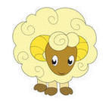](http://www.google.com.tr/url?sa=i&rct=j&q=&esrc=s&source=images&cd=&cad=rja&uact=8&ved=0ahUKEwjywqDI9NHJAhUKfRoKHX1tBZsQjRwIBw&url=http://tr.365psd.com/vector/funny-sheep-face-white-cartoon-52148&bvm=bv.109395566,d.bGg&psig=AFQjCNFMNMoIcp5pNrd69xcdJzuo7n5Xzw&ust=1449858125451736)[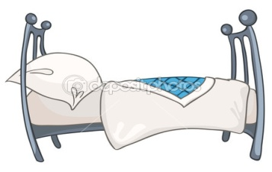](http://www.google.com.tr/url?sa=i&rct=j&q=&esrc=s&source=images&cd=&cad=rja&uact=8&ved=0ahUKEwj-_Oea9dHJAhUCtRoKHepDAKkQjRwIBw&url=http://tr.depositphotos.com/8899570/stock-illustration-cartoon-home-furniture-bed.html&bvm=bv.109395566,d.bGg&psig=AFQjCNEVLOHLqrcllqz7qkS-LAcl-Uowwg&ust=1449858302077803)

y..l..n y..rm.. ka..a ko..un y..t..k

[](http://www.google.com.tr/url?sa=i&rct=j&q=&esrc=s&source=images&cd=&cad=rja&uact=8&ved=0ahUKEwil8Y2W9NHJAhWBUhoKHQM5BZcQjRwIBw&url=http://media.jehaisleprintemps.net/talks/basquecamp-programmation/&bvm=bv.109395566,d.bGg&psig=AFQjCNEmU-F9QtUFgvnRKMALGX5LFiTbyA&ust=1449858019370099) [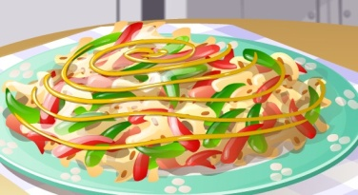](http://www.google.com.tr/url?sa=i&rct=j&q=&esrc=s&source=images&cd=&cad=rja&uact=8&ved=0ahUKEwjUlsiC9tHJAhXMVxoKHWRSASAQjRwIBw&url=http://www.temizlikoyunlari.tv.tr/yemek-oyunlari/1&bvm=bv.109395566,d.bGg&psig=AFQjCNGRjrRrpXdh7uw0wvSyBFV21tgsZg&ust=1449858454852778) [](http://www.google.com.tr/url?sa=i&rct=j&q=&esrc=s&source=images&cd=&cad=rja&uact=8&ved=0ahUKEwiO7Kqv9tHJAhVEPxoKHUNVCTIQjRwIBw&url=http://tr.123rf.com/photo_21827577_sevimli-yavru-kedi-bir-yumak-ile-oynuyor.html&bvm=bv.109395566,d.bGg&psig=AFQjCNEfrJ644Umrg4BHDSRMykiuYbn8ww&ust=1449858588970156) [](http://tr.depositphotos.com/58432859/stock-illustration-monkey-cartoon.html)

[](http://www.google.com.tr/url?sa=i&rct=j&q=&esrc=s&source=images&cd=&cad=rja&uact=8&ved=0ahUKEwi607z79tHJAhVJWBoKHZ4PAUMQjRwIBw&url=http://tr.depositphotos.com/35860031/stock-photo-smiling-cute-moon-with-sleeping.html&bvm=bv.109395566,d.bGg&psig=AFQjCNEtR26u84fV1xqdhr9cCec3CFqXRA&ust=1449858770950717)y..m..r..a y..m..k y..m..k ma..m..n

[](http://www.google.com.tr/url?sa=i&rct=j&q=&esrc=s&source=images&cd=&cad=rja&uact=8&ved=0ahUKEwi9vYnZscXJAhUBuhoKHUe3BpIQjRwIBw&url=http://tr.depositphotos.com/9086131/stock-photo-foot-cartoon-character.html&bvm=bv.108538919,d.bGQ&psig=AFQjCNE3gfNEPRTH5BOd8I7rDFs8KppP-w&ust=1449427862140786)[](http://www.google.com.tr/url?sa=i&rct=j&q=&esrc=s&source=images&cd=&cad=rja&uact=8&ved=0ahUKEwipmY-Q99HJAhVDMhoKHVEuCpAQjRwIBw&url=http://tr.clipart.me/premium-transportation/road-cartoon-vector-and-illustration-isolated-on-white-background-334974&bvm=bv.109395566,d.bGg&psig=AFQjCNHseqtS3B2Rgu5z5YZxCT6DLdArjA&ust=1449858815292826)[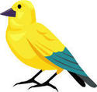](http://www.google.com.tr/url?sa=i&rct=j&q=&esrc=s&source=images&cd=&cad=rja&uact=8&ved=0ahUKEwii-JHGscXJAhXKOxoKHVDuAWMQjRwIBw&url=http://tr.clipartlogo.com/premium/detail/canary_44874868.html&bvm=bv.108538919,d.bGQ&psig=AFQjCNHiNXcuvgICYNxik1AUTKNl-TSPdg&ust=1449427807897126)[](http://tr.depositphotos.com/27382417/stock-illustration-cute-baby-bear-cartoon.html)

[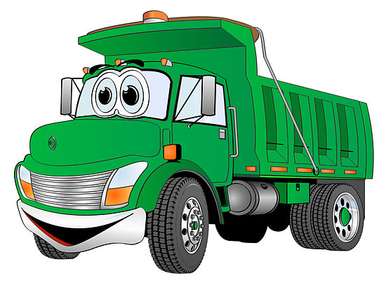](http://www.google.com.tr/url?sa=i&rct=j&q=&esrc=s&source=images&cd=&cad=rja&uact=8&ved=0ahUKEwjqxeKUyMfJAhWJnBoKHZIjCrkQjRwIBw&url=http://www.cliparthut.com/cartoon-propane-truck-clipart.html&bvm=bv.108538919,d.d2s&psig=AFQjCNFVaA5GoksGbXI1csWUgYlRE-nrSg&ust=1449502582893560) y..l a..ı a..ak a.. k..n..r..a

[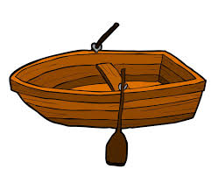](http://www.google.com.tr/url?sa=i&rct=j&q=&esrc=s&source=images&cd=&cad=rja&uact=8&ved=&url=http://watermens.org/sumer-camps/&bvm=bv.109395566,d.bGg&psig=AFQjCNE6c_dK_MTMEVS6N1HG4f0eIQvHjg&ust=1449858985923191)[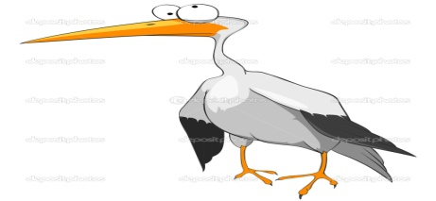](http://www.google.com.tr/url?sa=i&rct=j&q=&esrc=s&source=images&cd=&cad=rja&uact=8&ved=0ahUKEwjqy667s8XJAhVJ2hoKHZ9gAwEQjRwIBw&url=http://depositphotos.com/6414649/stock-illustration-cartoon-character-funny-stork.html&psig=AFQjCNHTtkRBFCcF27dYUtaOgMnNIDiOig&ust=1449428336543179)[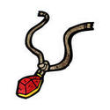](http://www.google.com.tr/url?sa=i&rct=j&q=&esrc=s&source=images&cd=&cad=rja&uact=8&ved=0ahUKEwiLsPeygcfJAhXE2xoKHRFhDwAQjRwIBw&url=http://tr.clipartlogo.com/premium/detail/cartoon-ruby-ring_116266819.html&bvm=bv.108538919,d.d2s&psig=AFQjCNHEYJZtpVA-3-oxjxzrOQkdUjaH2w&ust=1449483615376292)

[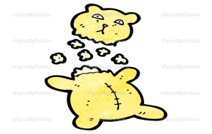](http://www.google.com.tr/url?sa=i&rct=j&q=&esrc=s&source=images&cd=&cad=rja&uact=8&ved=0ahUKEwjr8ebD-tHJAhVDuRoKHc0KD8QQjRwIBw&url=http://tr.depositphotos.com/21549179/stock-illustration-cartoon-torn-teddy-bear.html&bvm=bv.109395566,d.bGg&psig=AFQjCNGMhAq4GDqTyByKemwh6R2D0VdX1Q&ust=1449859729403362) k..l..e l..yle.. k..m..on ka..ık

y..rt..k