Ali İle Ata.
El ele Ali, el ele.
Ali ile Ata el ele.
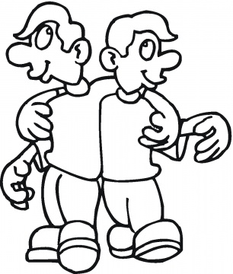
Tatile Ali, tatile.
El ele tatile.
Ali tel al.
Ata tel al.
El ele tel al.

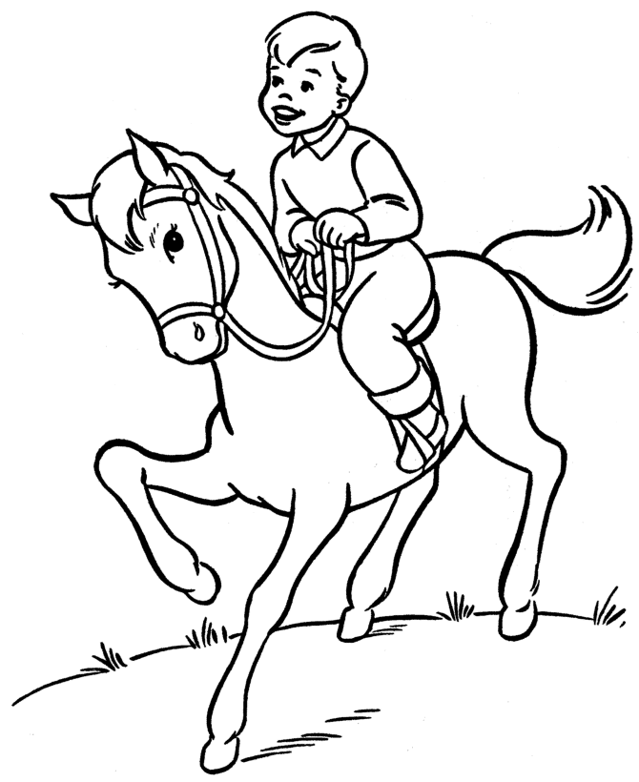
Ali At Al.
Al Ali, al.
Ali, at al.
Ali ala at al.
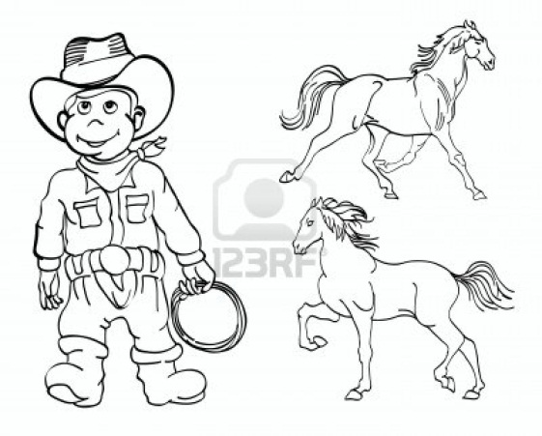
Ali elli at al.
Ali ata atla.

