RESİMLİ DİKTE ÇALIŞMASI

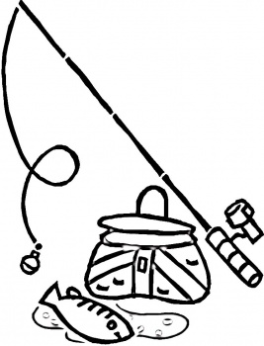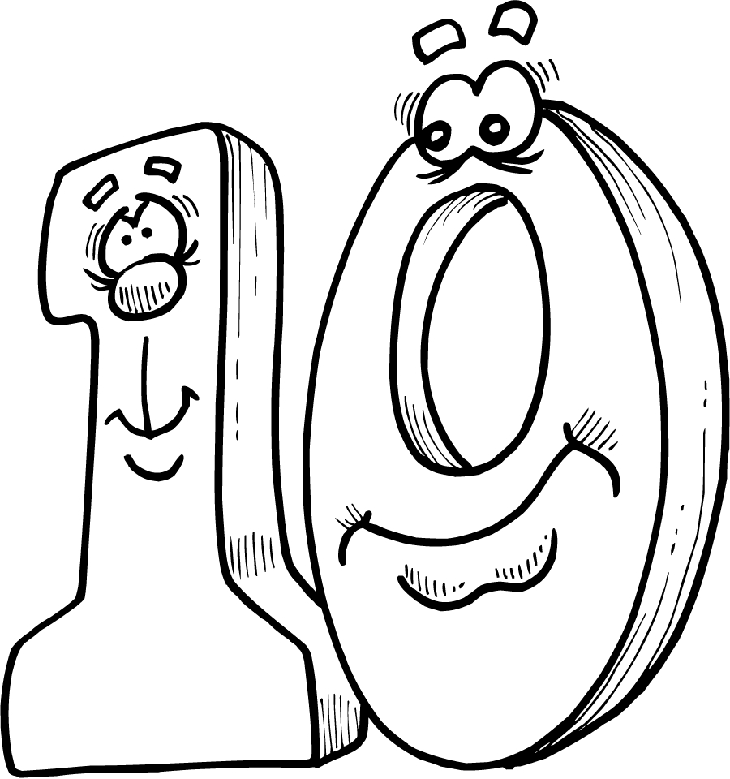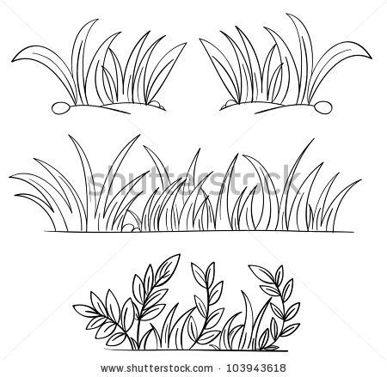

|  |
| --- |
|  |
|  |
|  |

|  |
| --- |
|  |
|  |
|  |

|  |
| --- |
|  |
|  |
|  |

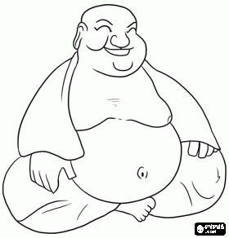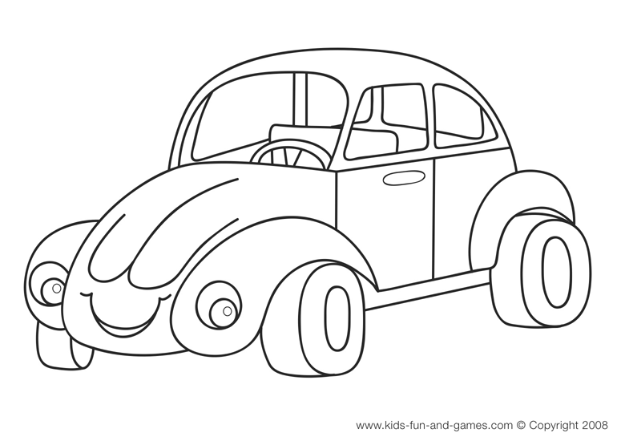

|  |  |  |  |  |
| --- | --- | --- | --- | --- |
|  |  |  |  |  |
|  |  |  |  |  |
|  |  |  |  |  |



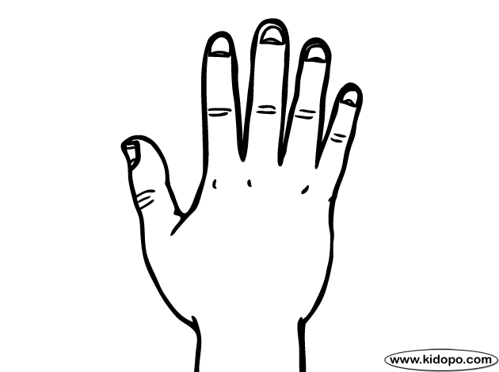

|  |  |  |  |  |
| --- | --- | --- | --- | --- |
|  |  |  |  |  |
|  |  |  |  |  |
|  |  |  |  |  |

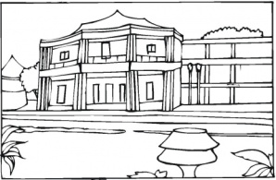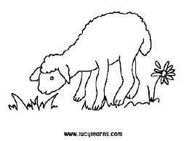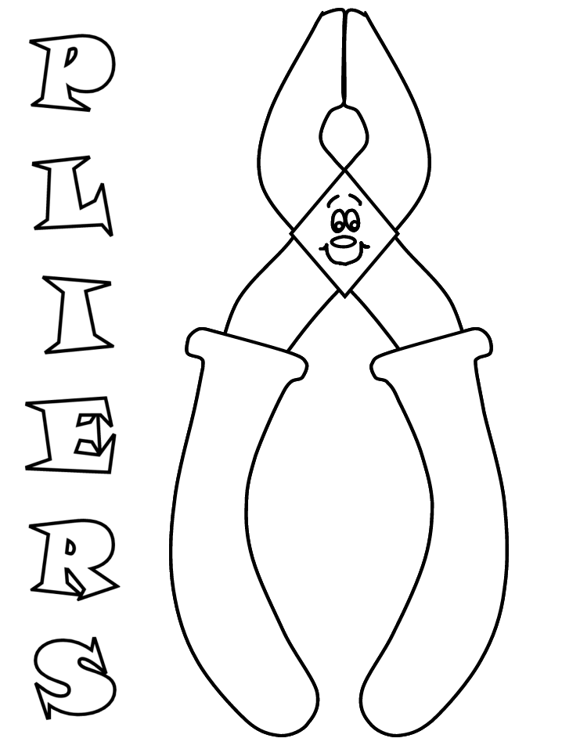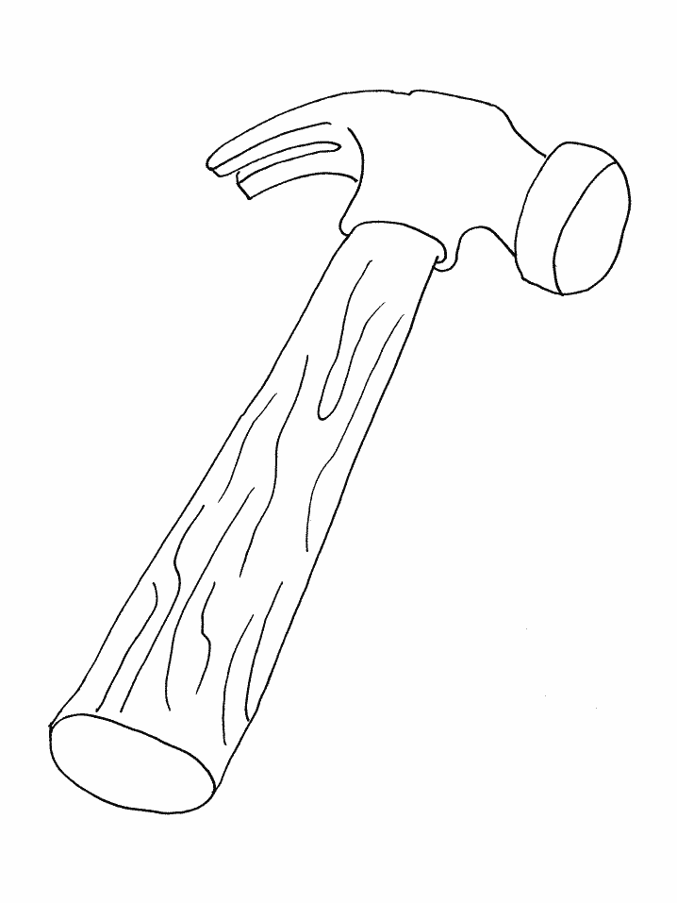



|  |  |  |
| --- | --- | --- |
|  |  |  |
|  |  |  |
|  |  |  |

Resimler: ot-on-olta-oto-tonton-not-onat-nota-alo-otel-otla