C:\Users\user\AppData\Local\Microsoft\Windows\Temporary Internet Files\Content.IE5\K4B68OAJ\MC900351446[1].wmfanne  
nal

anten

C:\Users\user\AppData\Local\Microsoft\Windows\Temporary Internet Files\Content.IE5\THDC9FQ3\MC900214997[1].wmf  
nine

C:\Users\user\AppData\Local\Microsoft\Windows\Temporary Internet Files\Content.IE5\THDC9FQ3\MC900024437[1].wmf

Nalan  
ile Nil



nane  
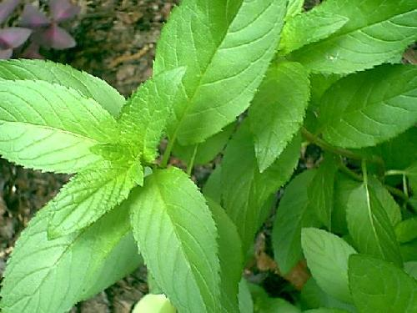 anlat  
