Nil 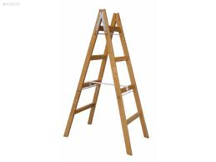 in
in Nil in
tin tin in.
tin tin at-la
ni-ne at-la
at-la ni-ne at-la
tin tin at-la
tin tin at-la
an-ne at-la
at-la an-ne at-la.
tin tin at-la
tin tin at-la

