***Al-tan nal al.***

***Al-tan el-li ta-ne nal al.***

***Al-tan 4 ta-ne nal al.***

***Al-tan a-ta nal al.***

***Al-tan na-ne-li j0215934 al.***

***Al-tan el-li ta-ne j0215934 al.***

***Al-tan a-ta na-ne-li j0215934 at.***

***Al-tan a-ta 4 ta-ne na-ne at.***

***A-li [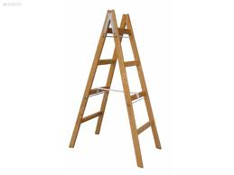](http://www.google.com.tr/imgres?q=tahta+merdiven&hl=tr&rls=com.microsoft:tr:IE-SearchBox&rlz=1I7GTKR_enTR435&biw=1024&bih=543&tbm=isch&tbnid=CqgoAuOaL9fv5M:&imgrefurl=http://www.sahibinden.com/ilan/alisveris-bahce-yapi-market-yapi-malzemeleri-a-tipi-tahta-merdiven-5-basamak-84199374/detay/&docid=lq_FBb_gF436xM&imgurl=http://image5.sahibinden.com/photos/19/93/74/big_84199374e68.jpg&w=800&h=600&ei=Nvu1UMSQIoSk4ATyu4Ag&zoom=1&iact=rc&dur=156&sig=100043513361781951340&page=2&tbnh=158&tbnw=159&start=8&ndsp=14&ved=1t:429,r:4,s:8,i:111&tx=110&ty=75) in.***

***A-li tin tin in.***

***a-li tin tin at-la***