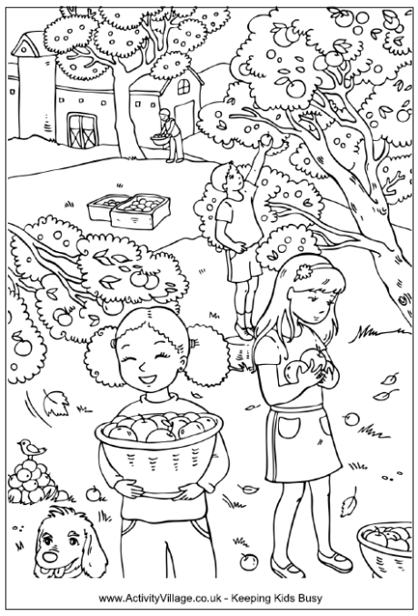
Mine ile Emine.
Mine mama al.
Emine mama al.
Mine on elma al.
Emine on tane al.
İri iri elma al.
Emine limon alma.
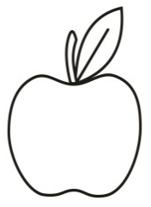
Mine tane tane elma al.
Elma tart elma al.
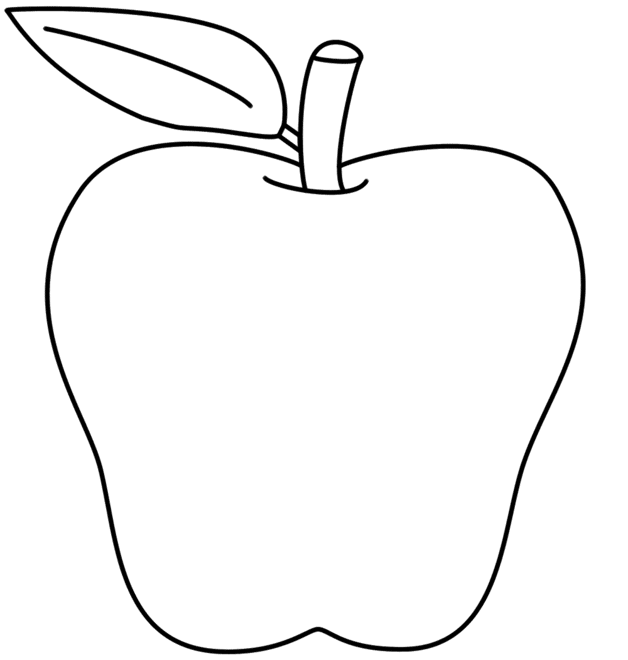
Narlar iri iri.
O Mine’nin.
O elma ninemin
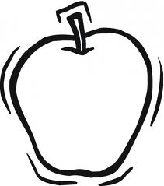
Elma
Emine on lira al.
Elma al limon al.
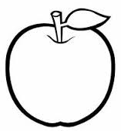
Mantar al nane al.
Mine ile elma al.
Limon ile elma al.
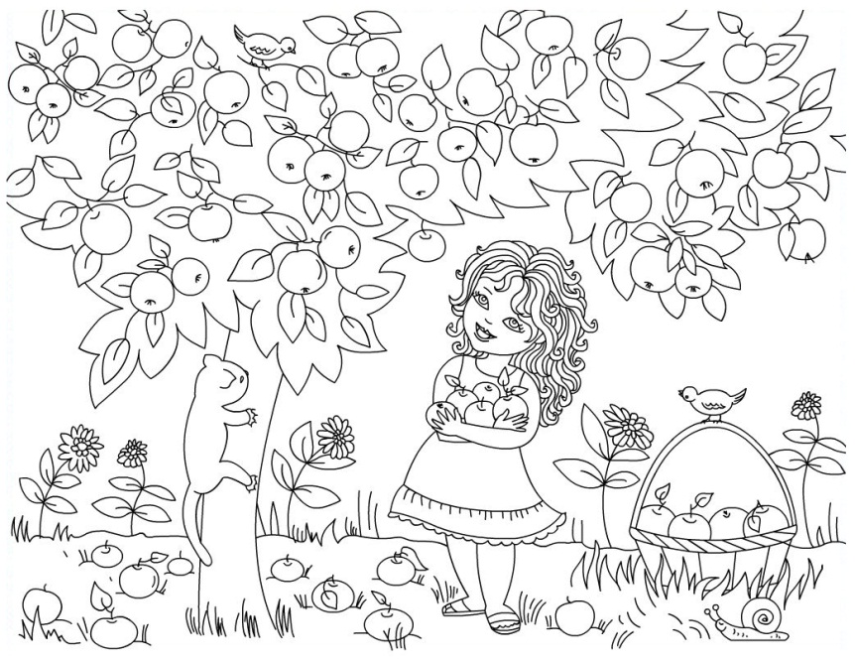
Elmalar iri iri.

