at

C:\Users\özgem\AppData\Local\Microsoft\Windows\Temporary Internet Files\Content.IE5\WR1YWMQX\MC900034089[1].wmf

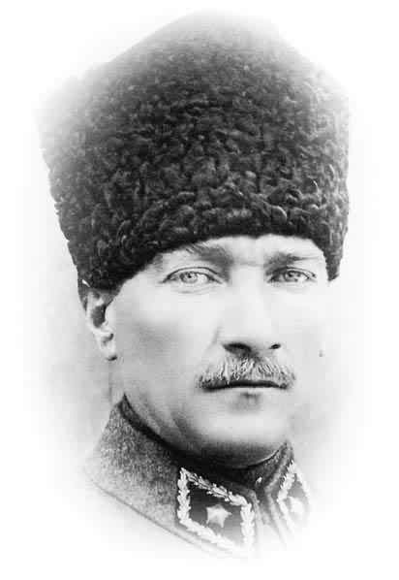

Ata

C:\Users\özgem\AppData\Local\Microsoft\Windows\Temporary Internet Files\Content.IE5\T4TKJO53\MC900232907[1].wmf

tat